ENTS 749B
Homework 5

- First, backup the /usr/local/lib/python2.7/dist-packages/ryu/app/simple_switch_13.py so that you keep the original version.
- Run the ryu controller with a copy of that module:
- cd ryu&& ryu-manager –verbose ryu/app/simple_switch_13.py
- Simulate a network with 3 switches and 2 hosts connected to each switch in mininet and use RYU as the controller with OpenFlow1.3 switches:
- $sudo mn –mac –topo linear,3,2 --switch ovs,protocols=OpenFlow13 --controller remote,ip=<ryu VM IP>
- Verify correct operation of the switch for ping traffic in S2 by dumping flows from S2 using ovs-ofctl and reviewing the installed flows.
- Use Homework 4 network and modify the simple_switch_13.py to implement a similar firewall function as in Homework 4. Submit similar items as in homework 4.

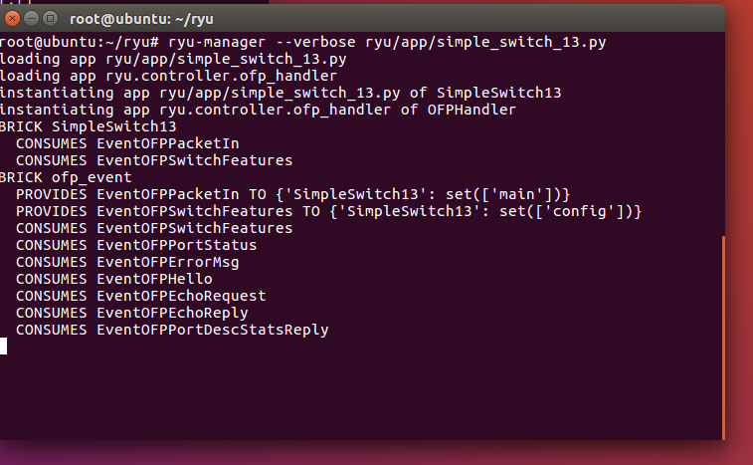

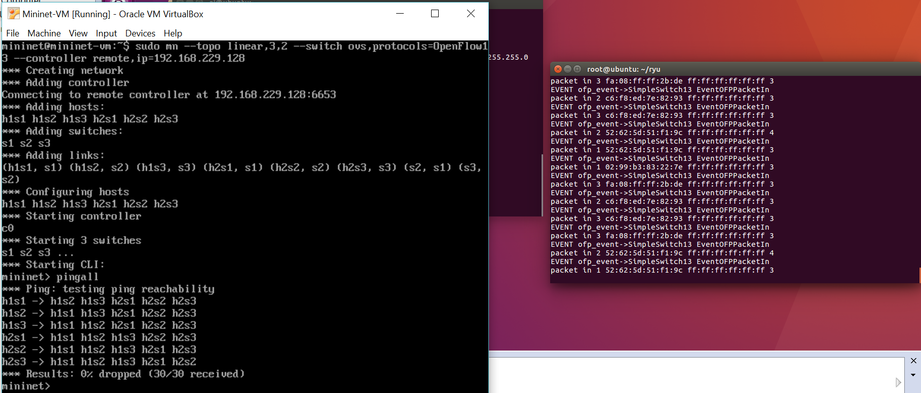

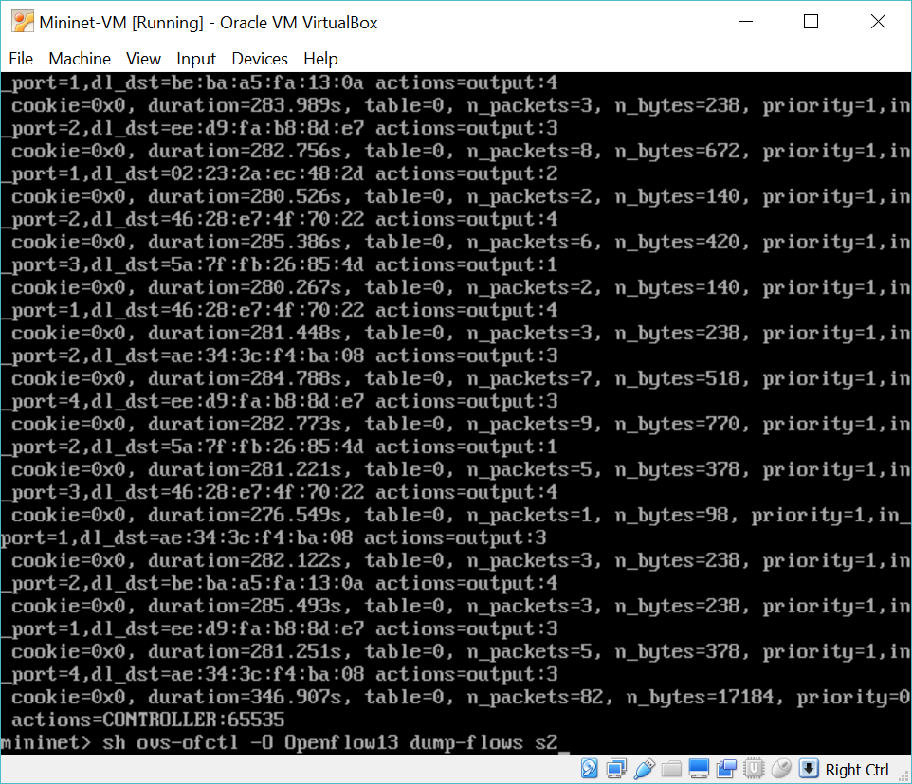

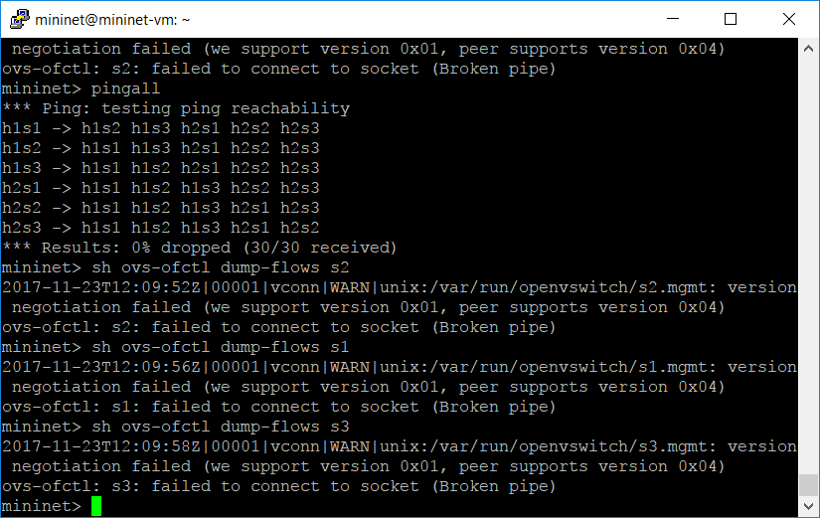

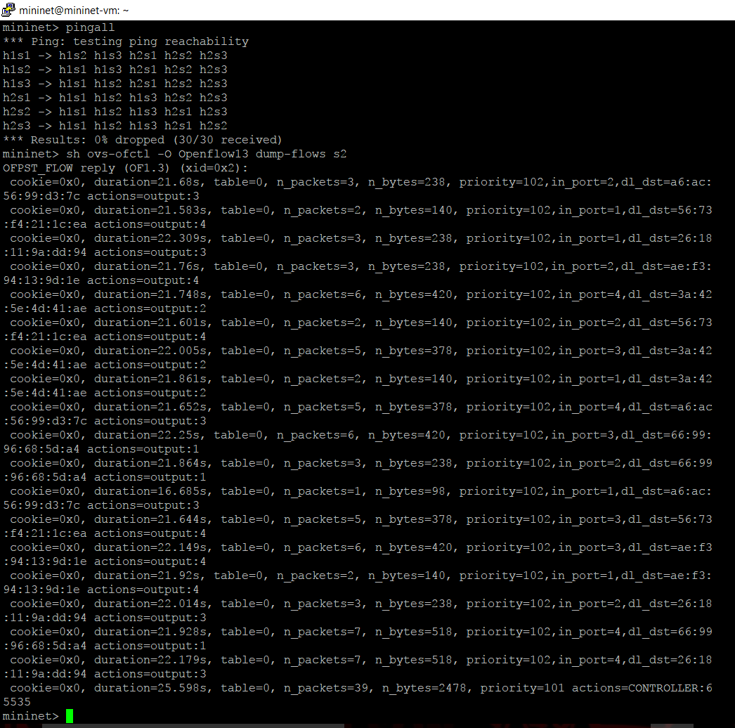

TASK 7

Firewall Operation Screenshots
Loading topology
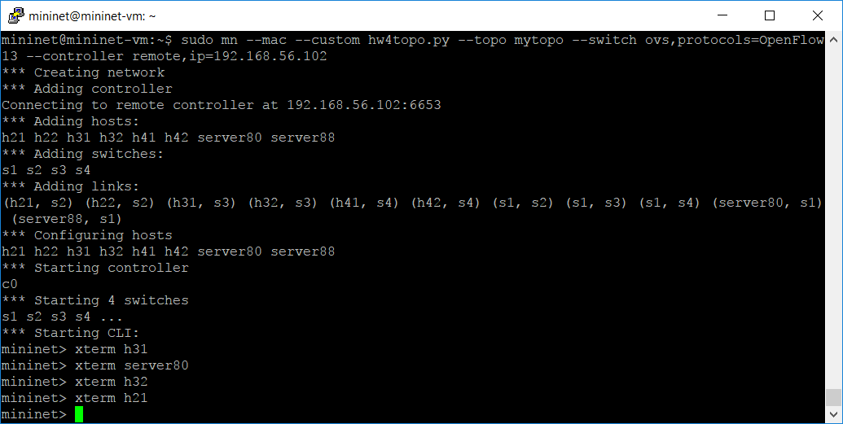

Running Server, and HTTP request from h31 and h21
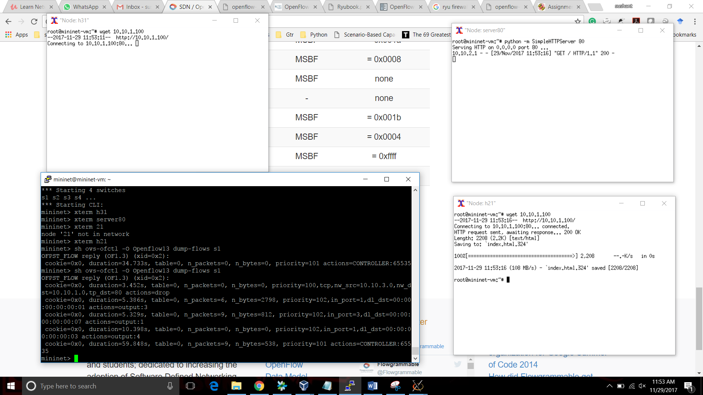

DumpFlows of S1
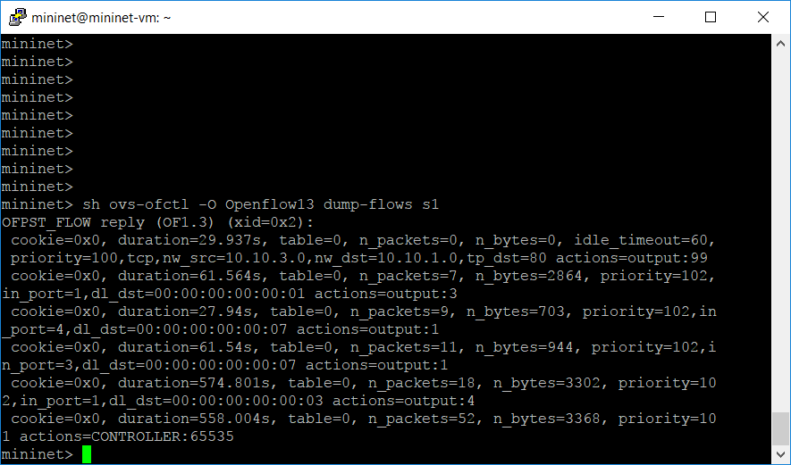

H31 attempting HTTP to server80:

H21 HTTP request Successful:

